Submission Deadline is Monday - August 27th!

Summer is here and in a blink it will be over.
Friends of Florissant Fossil Beds
2018 Benefit Fine Art Show & Sale

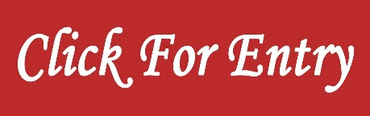

To Submit: Send 6-8 images of paintings that represent your work, fill out the submission form and pay you submission fee via PayPal. It is easy. Click above for all the details.
Event Dates: October 5 through October 7, 2018
Location: Florissant Fossil Beds National Monument Park Visitors Center - Florissant, Colorado

We are now accepting submissions for the annual
Friends of the Florissant Fossil Beds National Monument Juried Art Show.
This is an opportunity and honor for selected artists to display and sell their artwork along side nationally acclaimed artist:
Terri Sanchez.
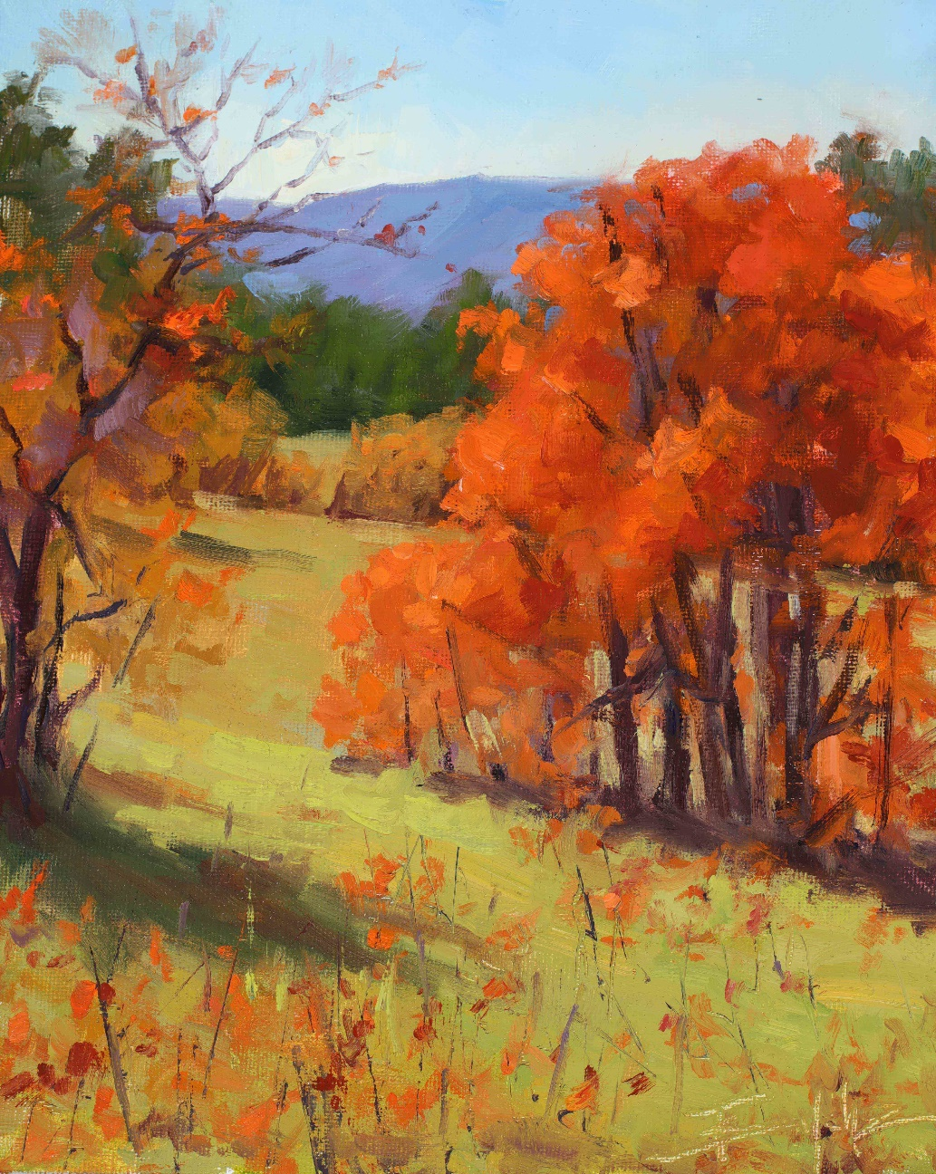
Featured Artist: Terri Sanchez.
Artists' Web Site: http:// www.TerriSanchez.com
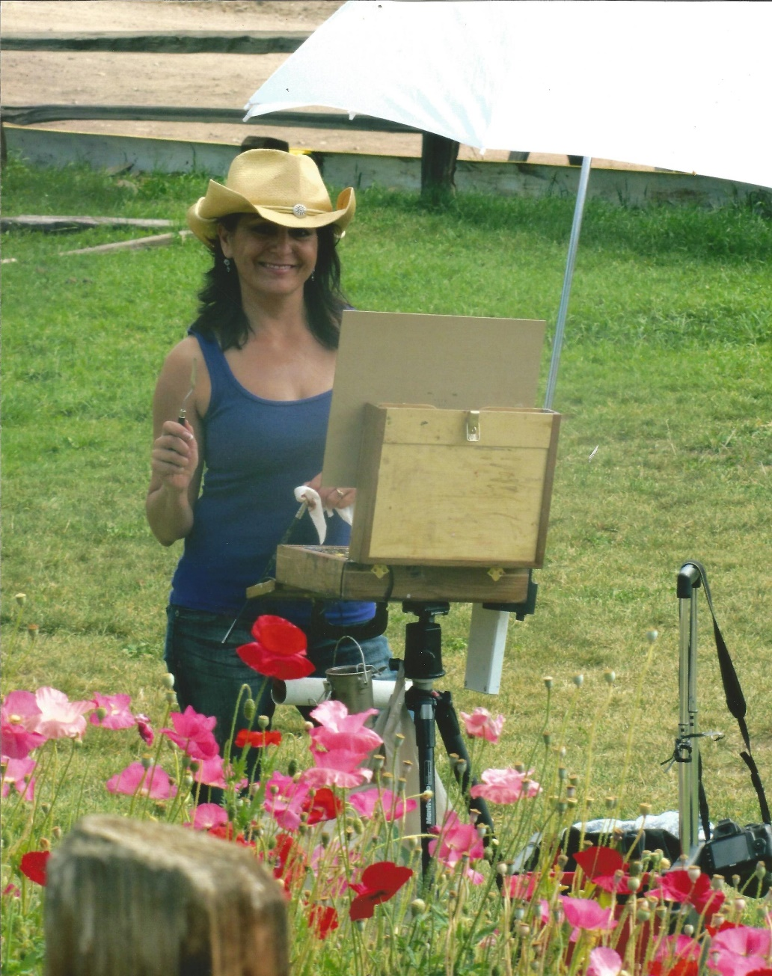
Participating Artists include Members of
The Pikes Peak Plein Air Painters
and juried artists from all over the nation.
This is a juried event.
Last year 25 paintings were sold!
This is what you need to do now to apply!

Click the link below to go to the PPPAP web site for complete details.

Submissions, Application & Fees
Two artist categories: Professional and Emerging Artists (student)
Three Fee Categories: PPPAP Members, Non- PPPAP Members & Student

There are advantages to submitting early!

Young Artists & Students, we have a special "Emerging Artists" category. Call Ken for details.
Do not delay. Apply now, spaces will fill.

For additional information contact:
Kenneth Shanika - Director of the PPPAP
303-941-8300 EMAIL: Ken@ShanikaFineArts.com
www.PikesPeakPleinAirPainters.com
Fossil Beds National Monument, The Friends of Florissant Fossil Beds and The Pikes Peak Plein Air Painters invite you to join our annual juried show. It is a themed show. The juror’s decision is final. Jury fees are non refundable regardless of outcome. The Friends of Florissant Fossil Beds reserves right to decline work that does not meet prospectus criteria. Entry constitutes the use of art images for the art show publicity purposes without further compensation. Although care will be taken, the sponsors will not be responsible for loss, theft or damage to artwork. Personal insurance is encouraged.

